EVIDENCE BUNDLE 3
Board Reporting
One-Page Executive Summary · Five Security Metrics · Priority Risks & Recommendations · Metric Selection Rationale
GlobalHealth Connect (GHC)
Executive Governance Simulation
Prepared by: Oluwatosin Olajubu
September 2026

3.1 Board Executive Summary
Overall Security Posture:
RED
GHC's overall information security posture is assessed as Red. The six-month security data indicates a deteriorating threat environment and increasing exposure to cyber risk. Phishing activity has increased from 150 incidents in September to 320 in February. Malware incidents have doubled from 25 to 50 over the same period. High-risk security incidents have also increased from two to seven.
At the same time, the organisation's patching performance has declined from 67% to 55%, despite an increasing number of critical vulnerabilities requiring remediation. Although security awareness training completion has improved from 45% to 70%, this improvement has not yet translated into a reduction in phishing or malware activity.
The combination of increasing threats, declining patching performance and rising high-risk incidents presents a significant risk to GHC's operations, sensitive patient information and customer trust.

Priority Risks
- Increasing exposure to cyber incidents due to the growing number of phishing and malware events.
- Delayed remediation of critical vulnerabilities due to declining patching performance.

Board-Level Recommendations
- Prioritise investment in vulnerability remediation and establish clear accountability for critical patching performance.
- Strengthen phishing and malware prevention through improved technical controls, targeted awareness training and regular monitoring.
- Require monthly executive review of high-risk incidents and remediation progress until security performance improves.

3.2 Selected Security Metrics

Metric 1: Phishing Incidents
 | Sep | Oct | Nov | Dec | Jan | Feb
Phishing Incidents | 150 | 180 | 210 | 250 | 280 | 320
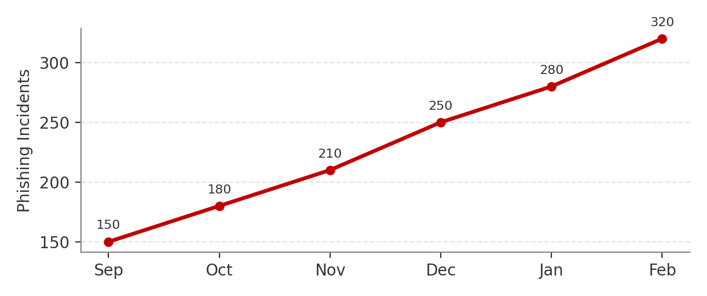
Trend: Increasing significantly.
Phishing incidents increased by more than 100% over six months. This indicates that GHC's exposure to social engineering attacks is growing and could result in credential compromise, financial loss or unauthorised access to sensitive information.

Metric 2: Malware Incidents
 | Sep | Oct | Nov | Dec | Jan | Feb
Malware Incidents | 25 | 30 | 35 | 40 | 45 | 50
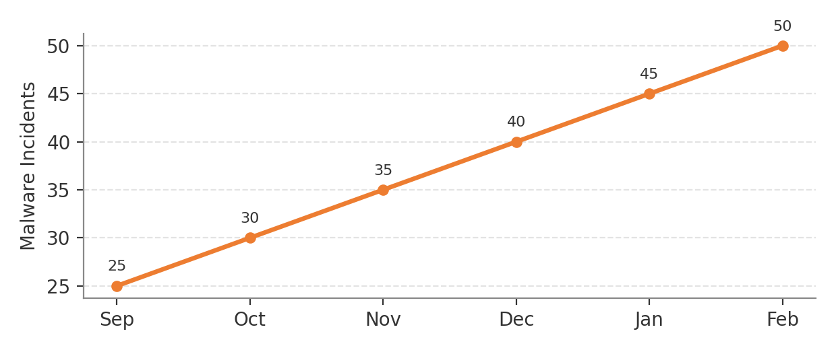
Trend: Consistently increasing.
Malware incidents doubled during the reporting period. This suggests increasing exposure and potentially insufficient preventative or detection controls.

Metric 3: Critical Vulnerabilities Patched
 | Sep | Oct | Nov | Dec | Jan | Feb
Patched of Total | 10 of 15 | 12 of 20 | 15 of 25 | 18 of 30 | 20 of 35 | 22 of 40
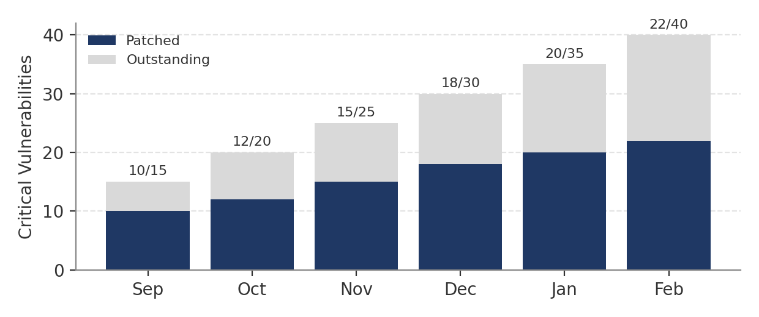
Trend: The number of vulnerabilities being addressed is increasing, but the backlog is growing faster than remediation efforts.
The organisation is identifying and patching vulnerabilities, but the number of outstanding critical vulnerabilities continues to increase. This creates a growing attack surface and requires management attention.

Metric 4: Patching Performance
 | Sep | Oct | Nov | Dec | Jan | Feb
Patching Performance | 67% | 60% | 60% | 60% | 57% | 55%
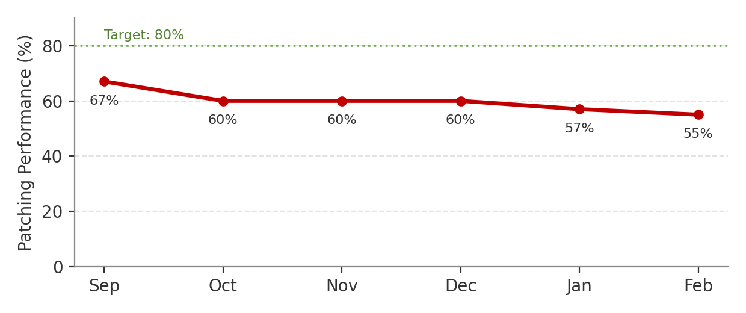
Trend: Declining.
Patching performance has declined from 67% to 55%. Given the increasing number of critical vulnerabilities, this represents a significant governance concern and increases the likelihood of exploitation.

Metric 5: High-Risk Security Incidents
 | Sep | Oct | Nov | Dec | Jan | Feb
High-Risk Security Incidents | 2 | 3 | 4 | 5 | 6 | 7
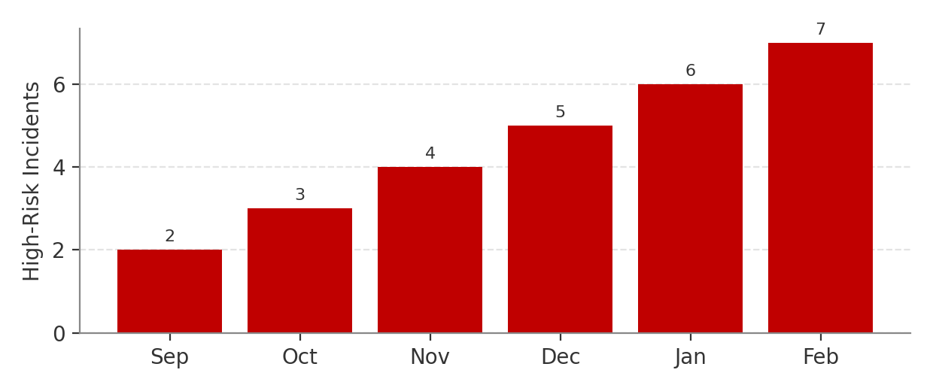
Trend: Increasing consistently.
High-risk incidents have increased steadily throughout the reporting period. This is the most significant Board-level outcome metric because it demonstrates that security risks are increasingly translating into incidents with potentially material business impact.

3.3 Metric Selection Rationale
The five selected metrics were chosen because they provide the Board with a balanced view of threat exposure, control effectiveness and business risk.
Phishing and malware incidents demonstrate changes in the external and internal threat environment. Critical vulnerability remediation and patching performance provide insight into GHC's ability to manage known technical weaknesses. High-risk incidents provide an outcome-focused measure of whether security risks are affecting the organisation.
These metrics are suitable for Board oversight because they show trends over time and can support strategic decisions regarding investment, risk prioritisation and management accountability.

